**Data Model: Property Rule**

**Property Rule:**

* **Property is a Data Model Rule**
* **Property is like a variable in other programming languages**
* **A Property holds a user input Value at run time.**
* **Property Rule is an Instance of Rule-Obj-Property**

**Property Types:**

**- Single Value:  A Property can hold one value at a time**

**- Page Properties (Single Page, Page List, Page Group): A Property can hold Multiple Properties (Reusable Properties)**

**- Adv Properties: Value List, Value Group: A Property can hold Multiple Values**

**How many ways to add Property:**

**3 ways:**

**- Data Model-Property (Create a Property: Create & Open) - One Property   (Single Value, Page & Adv Properties)**

**- *Data* Model-Property (Quick Create a Property: Create & Close)- One Property ( Single Value)**

**- Using Property Wizard - Multiple Properties at a time (But we can add only single value properties using wizard Option/ Page Properties)**

**Single Value Property  Parameters:**

**Property is associated with below parameters:**

* **Property Name/Label: Ex: FName**
* **Property Type:  Ex: Text**
* **UI Control:  Property Display Format & Basic Validation**
* **Table Type/Configure Field:  To add Static Records for Property ( Local List / Prompt List)**

========

**Creating Single Value Properties Using Property Wizard:**

**To Create any Rule in PEGA go to App Explorer:**

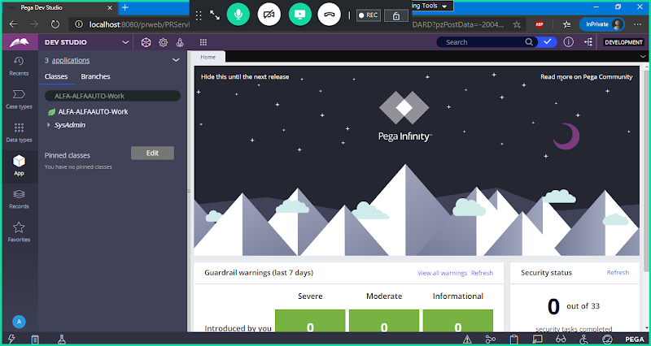

**Till 7.4- (  Right Click on Class group -> Create Properties)**

**From 8 Version-> Wizard Name is View in Data Designer/Create Properties**

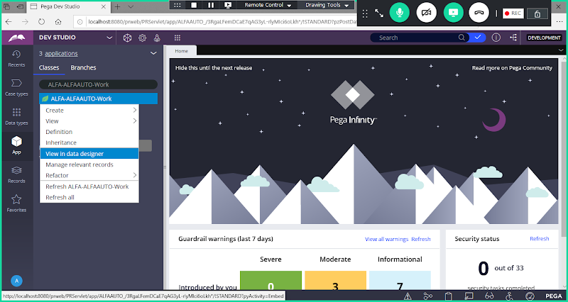

**Wizard will open**

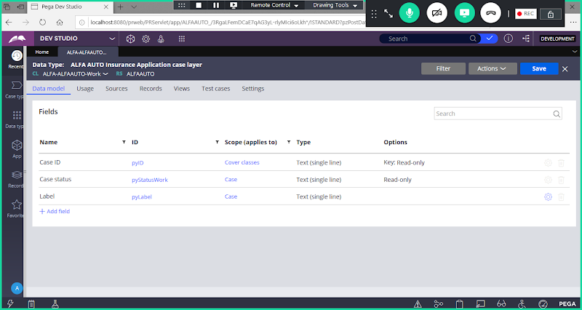

**Add Fields/Properties**

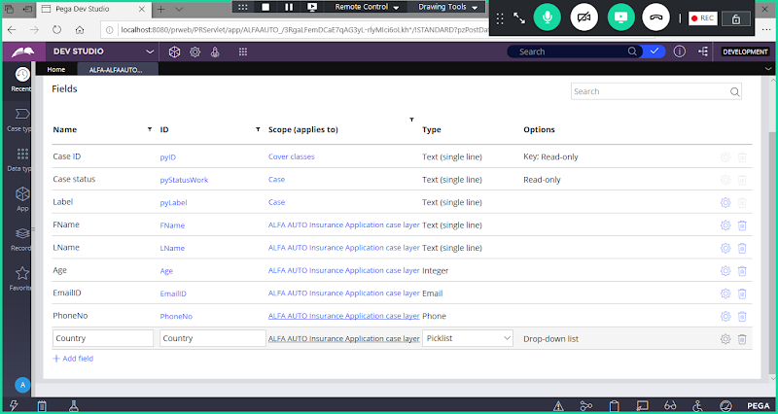

**For Radio Buttons/ Drop drowns we have to choose a Type: Pick List**

**For Country Property If you want to Give Dropdown Control set the Type as Pick List.**

**After Type is Selected, Configure the Pick list Values (Click on Configure Filed)**

**Now Click on Configure Field**

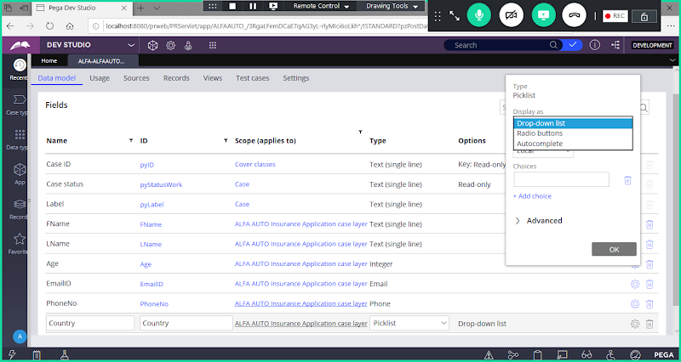

**Add Static Records:**

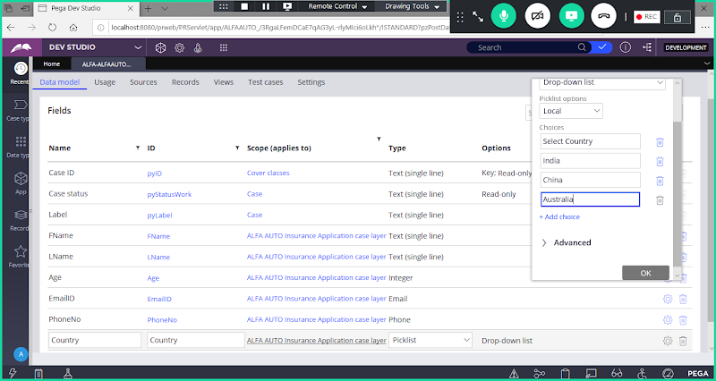

**Click on OK**

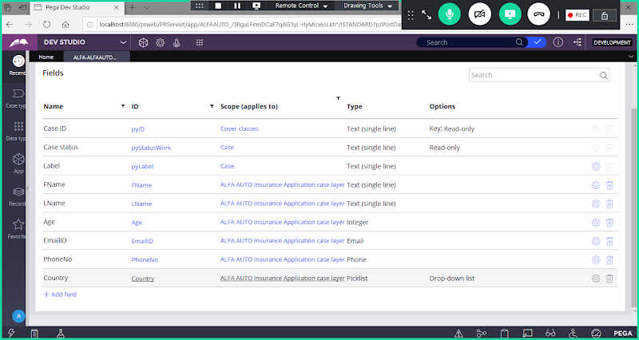

**Refresh Explorer & Expand Data Model to see the Properties**

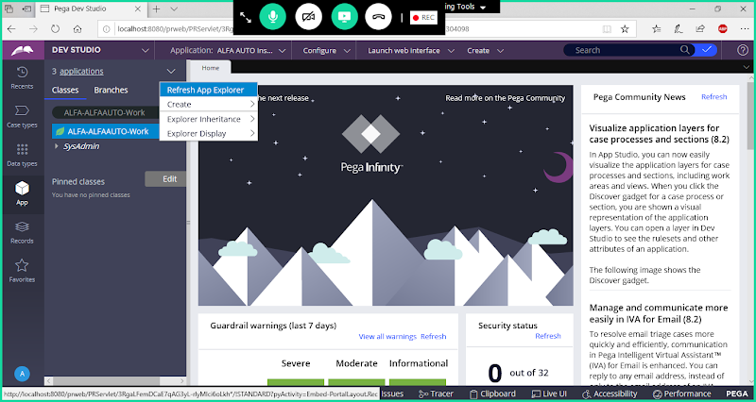

**Expand Data Model**

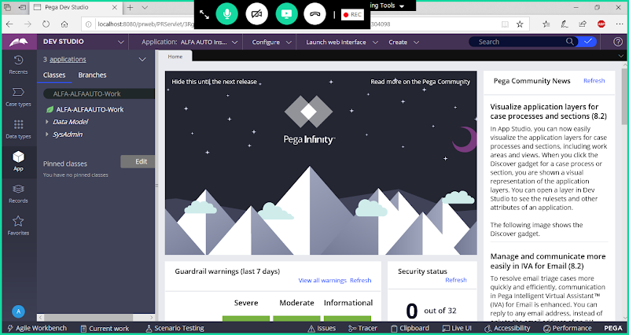

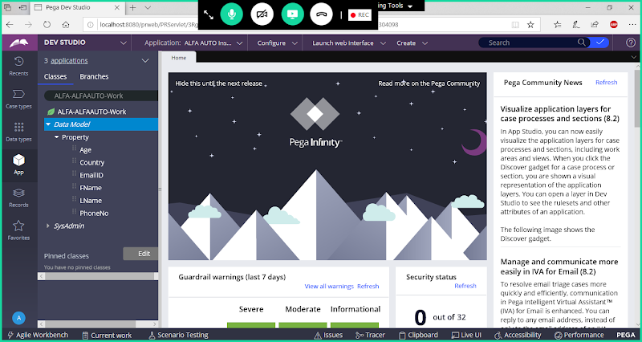

**Creating Properties Under Data Model Category using Property Rule:**

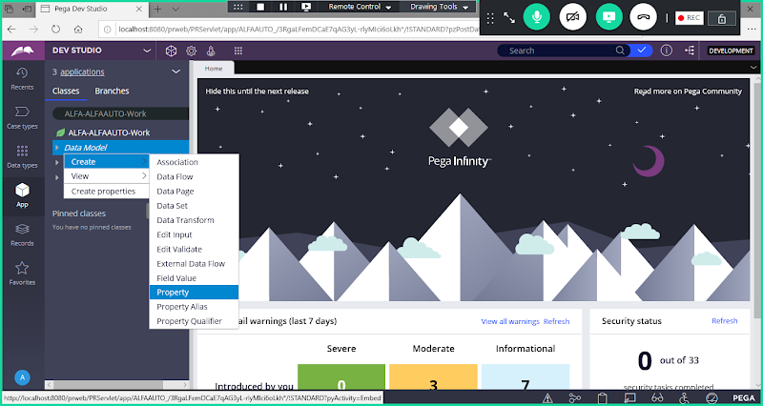

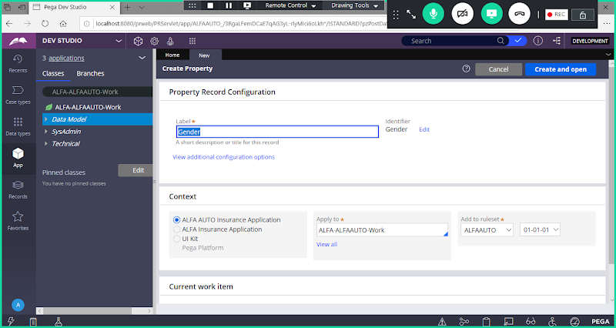

**Click on Create & Open**

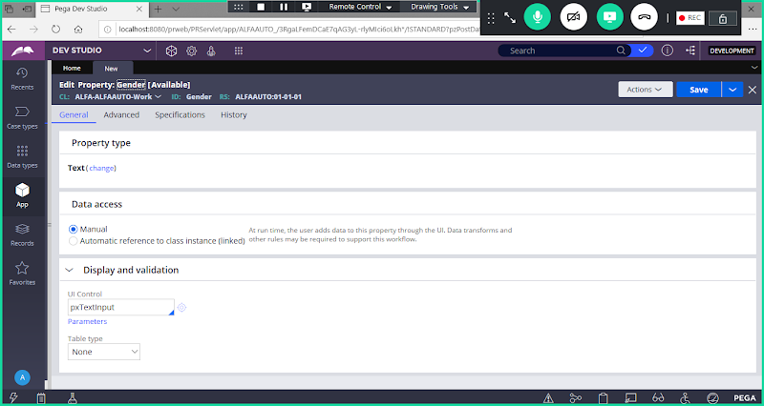

**Type: Text**

**UI Control: pxRadioButtons**

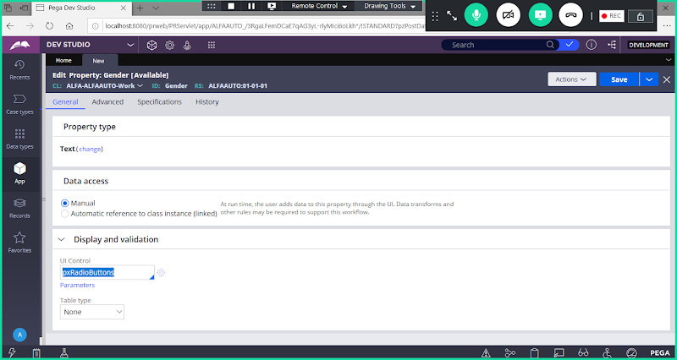

**TableType: Select Local List & Add Table Values**

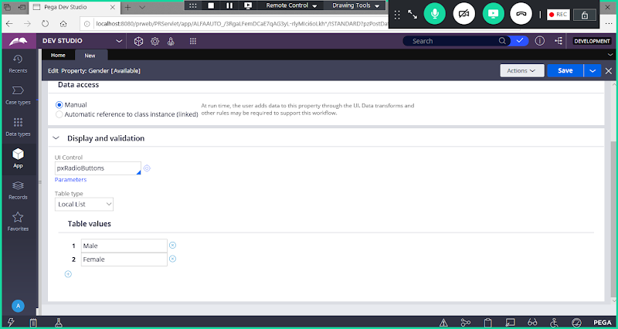

**Or Use PromptList under table type:**

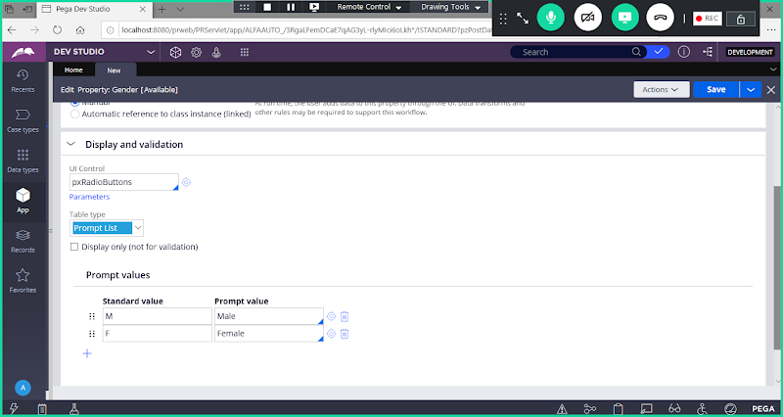

**Save Property**

**Add Pincode Using Quick Create Option:**

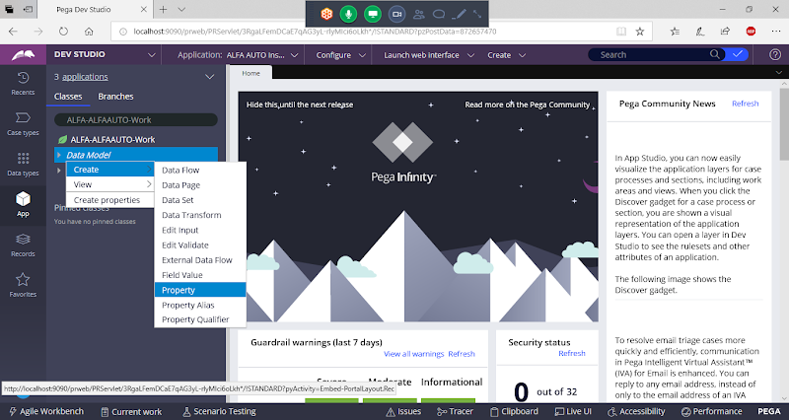

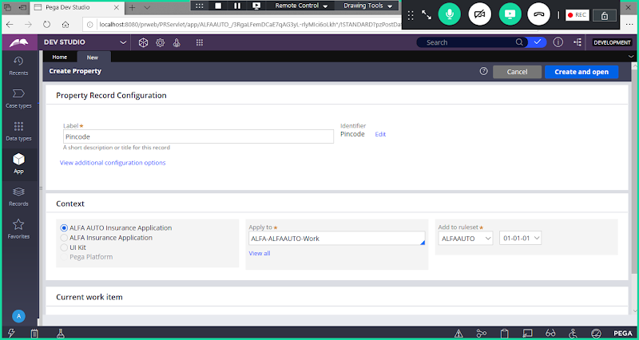

**Now Below Label Click on View Additional Configuration Options Link**

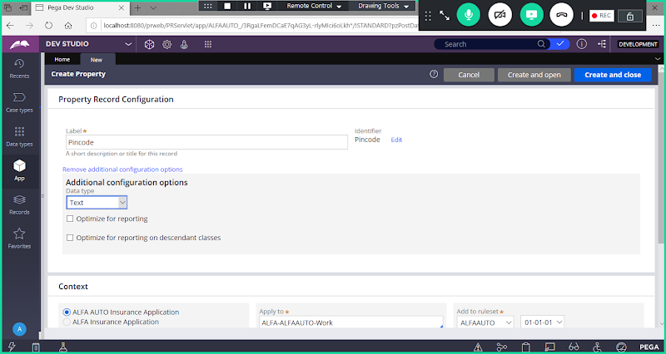

**No Need to Change type here.**

**Now Click on Create & Close Button, After Clicking on Button, Property will be created & tab will be closed.**

**Add State & City Properties using Drop down & Add static Records**

Open Property Wizard:

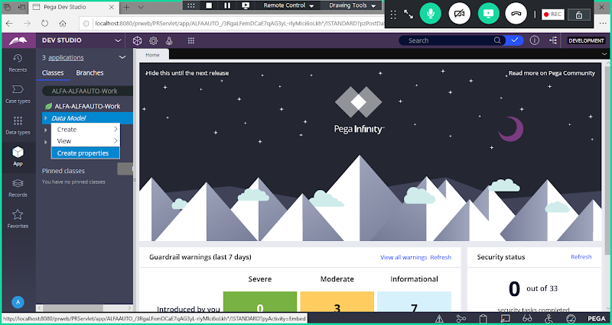

**Add State Property:**

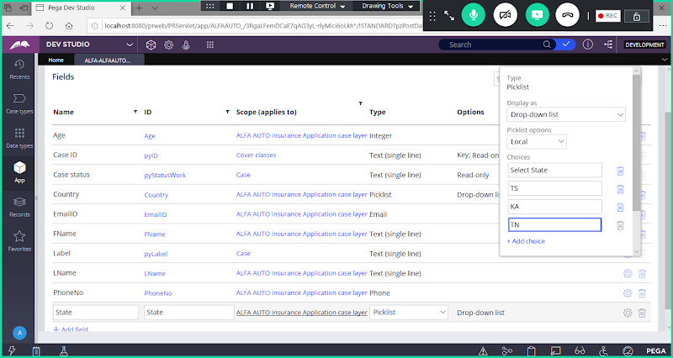

Add City Field:

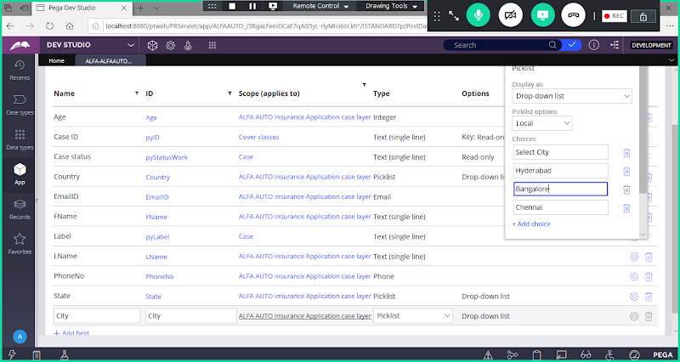

**After Creating Properties, to view all properties under Data Model , Clcik on Refresh App Explorer**

